1. | Create class as Person with name and age as data members. Write parameterized  Constructor for set the value of data and getPerson method for show the data.
Code | <html>  <body>  <script>  class person{  constructor(name,age){  this.name=name;  this.age=age;  }  getPerson(){  document.writeln("Person name:",this.name);  document.writeln("<br>Person age:",this.age);  }  }  const p1=new person("Mit",21);  p1.getPerson();  </script>  </body>  </html>
Output | 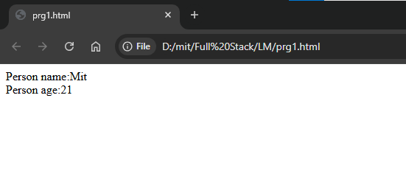
2. | Create class as Student with name and rno as data members. Write default  constructor for initialize the value as blank. Set the value of data using setStudent  method and show the value of data using getStudent method.
Code | <!DOCTYPE html>  <html lang="en">  <head>  <meta charset="UTF-8">  <meta name="viewport" content="width=device-width, initial-scale=1.0">  <title>Document</title>  </head>  <body>  <script>  class student{  constructor(){  this.name="";  this.rno="";  }  setStudent(name,rno){  this.name=name;  this.rno=rno;  }  getStudent(){  document.writeln("student name:",this.name);  document.writeln("<br>student mo:",this.rno);  }}  const s1=new student();  s1.setStudent("mit",21);  s1.getStudent();  </script>  </body>  </html>
Output | 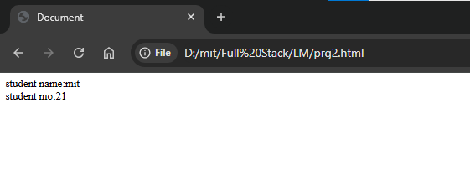
3. | Create class company with name, type and profit as data members. Write  getCompany and setCompany method for set and show the data.
Code | <html>  <body>  <script>  class Company {  setCompany(name, type, profit) {  this.name = name; // use parameter values  this.type = type;  this.profit = profit;  }  getCompany() {  document.writeln("Company name: " + this.name);  document.writeln("<br>Company type: " + this.type);  document.writeln("<br>Company profit: " + this.profit);  }  }  const s1 = new Company();  s1.setCompany("Zara", "Fashion", "20cr");  s1.getCompany();  </script>  </body>  </html>
Output | 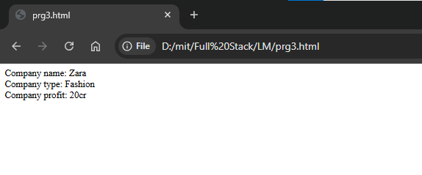
4. | Create parent class as Cricketer with Cid, cname and country as data member. Write  Two methods as getCountry and setCountry. Create child class as bowler with wickets  And matches as data member. Write two methods as getBowler and setBowler.  Create another child class as Batsman with runs and matches as data members.  Write two methods as getBatsman and setBatsman. Create one object of Bowler  Class and one Object of Batsman class and show all information.
Code | <!DOCTYPE html>  <html lang="en">  <head>  <meta charset="UTF-8">  <meta name="viewport" content="width=device-width, initial-scale=1.0">  <title>Cricketer</title>  </head>  <body>  <script>  class Cricketer {  constructor(cid, name, country) {  this.cid = cid;  this.name = name;  this.country = country;  }  setCountry(country) {  this.country = country;  }  getCountry() {  return this.country;  }  }  class Bowler extends Cricketer {  setBowler(wickets, matches) {  this.wickets = wickets;  this.matches = matches;  }  getBowler() {  document.writeln("Bowler ID: " + this.cid);  document.writeln("<br>Name: " + this.name);  document.writeln("<br>Country: " + this.country);  document.writeln("<br>Wickets: " + this.wickets);  document.writeln("<br>Matches: " + this.matches);  }  }  class Batsman extends Cricketer {  setBatsman(runs, matches) {  this.runs = runs;  this.matches = matches;  }  getBatsman() {  document.writeln("<br><br>Batsman ID: " + this.cid);  document.writeln("<br>Name: " + this.name);  document.writeln("<br>Country: " + this.country);  document.writeln("<br>Runs: " + this.runs);  document.writeln("<br>Matches: " + this.matches);  }  }  const bowler1 = new Bowler(1, "Bumrah", "India");  bowler1.setBowler(250, 150);  bowler1.getBowler();  const batsman1 = new Batsman(2, "Virat", "India");  batsman1.setBatsman(25000, 280);  batsman1.getBatsman();  </script>  </body>  </html>
Output | 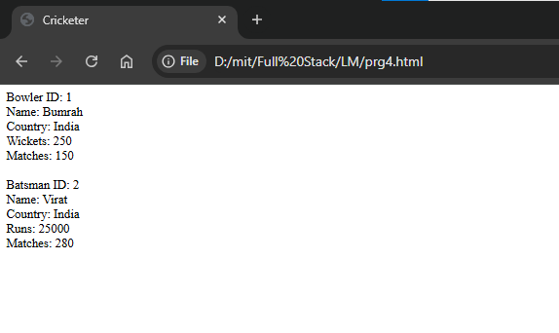
5. | Write down arrow functions for different arithmetic operations.
Code | <!DOCTYPE html>  <html lang="en">  <head>  <meta charset="UTF-8">  <meta name="viewport" content="width=device-width, initial-scale=1.0">  <title>Document</title>  </head>  <body>  <script>  const add=(a,b)=>a+b;  const sub=(a,b)=>a-b;  const mult=(a,b)=>a*b;  const div=(a,b)=>a/b;  const mod=(a,b)=>a%b;  document.writeln("a=5,b=10")  document.write("<br>Addition:",add(5,10));  document.write("<br>Substraction:",sub(5,10));  document.write("<br>Multiplication:",mult(5,10));  document.write("<br>Divition:",div(5,10));  document.write("<br>Mod:",mod(5,10));  </script>  </body>  </html>
Output | 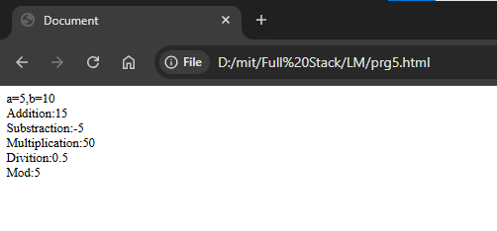
6. | Write down arrow functions for finding the area and perimeter of the circle.
Code | <!DOCTYPE html>  <html lang="en">  <head>  <meta charset="UTF-8">  <meta name="viewport" content="width=device-width, initial-scale=1.0">  <title>Document</title>  </head>  <body>  <script>  const ar=(r)=>3.14*r*r;  const pr=(r)=>2*3.14*r;  document.writeln("<br>Area of Circle :",ar(5));  document.writeln("<br>Perimeter of Circle :",pr(5));  </script>  </body>  </html>
Output | 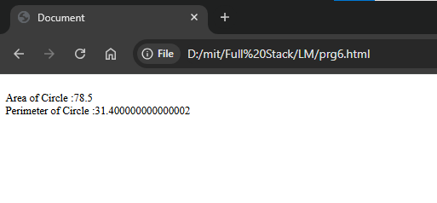
7. | Write different arrow functions to solve following equations.  a. X2+Y2+XY  b. (X+Y)-(Y+Z)  c. X2+Y2-2XY.
Code | <!DOCTYPE html>  <html lang="en">  <head>  <meta charset="UTF-8">  <meta name="viewport" content="width=device-width, initial-scale=1.0">  <title>Document</title>  </head>  <body>  <script>  document.writeln("x = 5 , y = 10")  const e1=(x,y)=>(x*x)+(y*y)+(x*y)  const e2=(x,y,z)=>(x+y)-(y-z)  const e3=(x,y)=>(x*x)+(y*y)-(2*x*y)  document.writeln("<br>1. x^2+y^2+xy : ",e1(5,10));  document.writeln("<br>2. (x+y)-(y+z) : ",e2(5,10,15));  document.writeln("<br>3. x^2+y^2-2xy : ",e3(5,10));  </script>  </body>  </html>
Output | 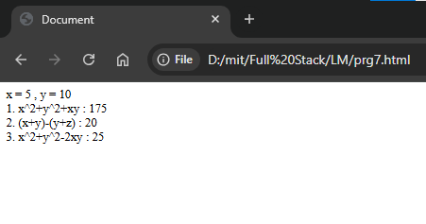
8. | Write a map function for finding the square of each array elements.
Code | <html>  <body>  <script>  const numbers = [1, 2, 3, 4, 5];  const squares = numbers.map(num => num * num);  document.write("Squares of [1,2,3,4,5] : ",squares);  </script>  </body>  </html>
Output | 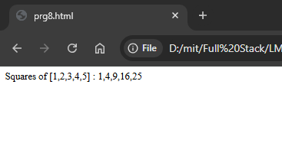
9. | Write map function for finding the factorial of each elements of array.
Code | <html>  <body>  <script>  function factorial(n) {  if (n === 0 || n === 1) return 1;  return n * factorial(n - 1);  }  const numbers = [1, 2, 3, 4, 5];  const factorials = numbers.map(factorial);  document.write("Factorial of [1,2,3,4,5] : ",factorials);  </script>  </body>  </html>
Output | 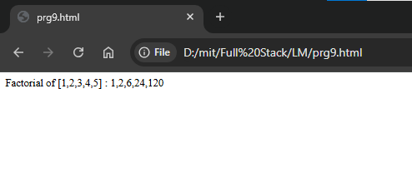
10. | Write map function for check element is prime or not for each elements of array.
Code | <html>  <body>  <script>  function isPrime(n) {  if (n <= 1) return false;  if (n === 2) return true;  if (n % 2 === 0) return false;  for (let i = 3; i <= Math.sqrt(n); i += 2) {  if (n % i === 0) return false;  }  return true;  }  const numbers = [1, 2, 3, 4, 5, 10, 13, 17];  const primeCheck = numbers.map(num => ({  number: num,  isPrime: isPrime(num)  }));  primeCheck.forEach(item => {  document.write(`${item.number} → ${item.isPrime ? "Prime" : "Not Prime"}<br>`);  });  </script>  </body>  </html>
Output | 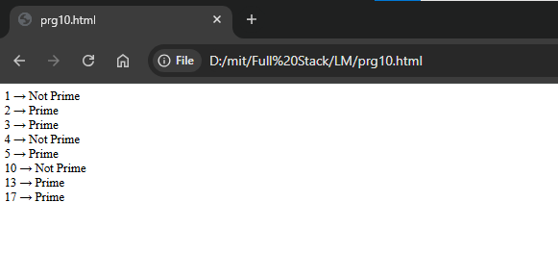
11. | Write map function for check element is odd or even for each elements of array.
Code | <html>  <body>  <script>  const numbers = [1, 2, 3, 4, 5, 10, 13, 17];  const oddEvenCheck = numbers.map(num => ({  number: num,  type: num % 2 === 0 ? "Even" : "Odd"  }));  oddEvenCheck.forEach(item => {  document.write(`${item.number} → ${item.type}<br>`);  });  </script>  </body>  </html>
Output | 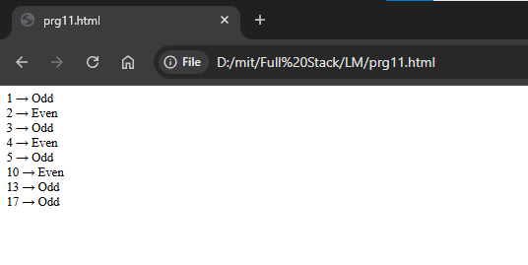
12. | Create studInfo.js file and write two functions as sayCollege and sayCourse. Export it and use it and show the proper message.
Code | Prg12.html:  <!DOCTYPE html>  <html lang="en">  <head>  <meta charset="UTF-8">  <meta name="viewport" content="width=device-width, initial-scale=1.0">  <title>Student Info</title>  </head>  <body>  <h1>Student Information</h1>  <script src="studinfo.js"></script>  </body>  </html>  Studinfo.js:  function sayCollege() {  document.write("I am studying at ISTAR.<br>");  }  function sayCourse() {  document.write("I am enrolled in the MCA course.<br>");  }  sayCollege();  sayCourse();
Output | 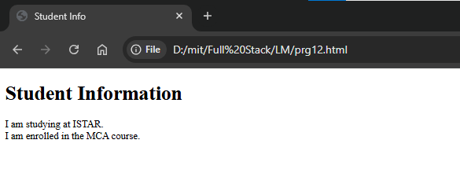
13. | Write a function component as Item with data as name, cost, and type. Write  another function component as feedback with data as id, title, detail, and rating.  Create another function component as ItemDetail and arrange above both  components in it. (Pass the data using props)
Code
Output
14. | Write a function component as Student with data as name, rno, and city. Write  another function component as Marks with data as m1, m2, m3, total, and per.  Create another function component as StudentDetail and arrange above both  components in it.(Pass the data using props)
Code
Output
15. | Create one main function component which includes three sub function components as per your choice. (Pass the data using props)
Code
Output
16. | Create a class component as Bank which set States as name, branch, and ifsc. Create the element of it and show all the details.
Code
Output
17. | Create a class component as Department with two states as iname and dname.  Assign default value as ISTAR and blank. Take two buttons MCA and IT. Set the state  (iname and dname) according to the click on button.
Code
Output
18. | Create class component as StateDetail with data as sname, capital, area, language,  Dance. Set a link for at least five states and show the above information (in proper  format) according to the click on link.
Code
Output
19. | Create your own class component with change the states effect.
Code
Output
20. | Create function components as home, about, contact and NoPage. Create function  component for layout. Create multi page application for these componets using  Router.
Code
Output
21. | Create class components as India, Australia, SouthAfrica, England and NewZeeland.  Each component have at least five players link which show information according to  clicked on it. The information of the player will be name, matches, run, 50s, 100s, and  wickets. Set Layout component and Routes for each country using inbuilt Route  package.
Code
Output
22. | Think about one real-life practical multi-page application as per your perception and  implement it using both class and Routes (similar like prog 21).
Code
Output
23. | Create function component as Item. Write different useState to initialize and change  the data like iname, caegory, and cost.
Code
Output
24. | Create function component as Pizza. Write one function as setPizze using useState to  initialize and change the data like name, type (small, medium, large), toppings, and  cost. The data will be change when user click on different buttons like (Margherita,  Farmhouse, Fresh Veggie, Paneer Makhani, Cheesy7). Crate functions for each button  like setMargherita for Margherita button. Call the setPizza function inside the  setMargherita and set the data(states) as per the category of pizza.
Code
Output
25. | Write react code hor reading the json file and set the content of it into react  component.
Code
Output

